

**22/SP-COP-2800 Java Programming**

**Assignment 1.2**

Document Version: 0.1

Version Date: August 20, 2022

Created By: Jonathan Gan

# Document Version Control

|  |  |  |  |
| --- | --- | --- | --- |
| Version | Date | Author | Rationale |
| 0.1 | 2022 AUG 20 | Jonathan Gan | First Draft |

# Document Purpose

The prompt asked us to display welcome to Java 5 Times

# Technical Specifications

## Purpose of Technical Implementation

Using *System.out.println(String) inside of a for loop*

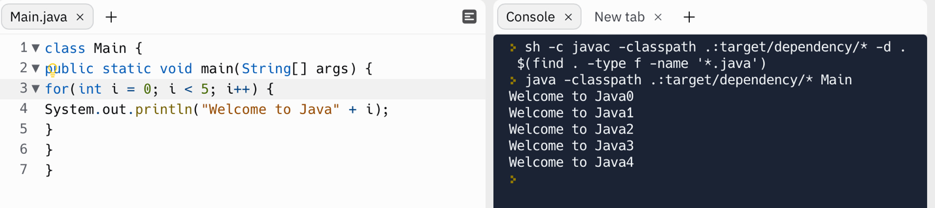

we were able to print out the string the specified number of times

REPL.IT URL:

https://replit.com/@jongan69/Assignment-12?v=1

## Technical Implementation Components

## Technical Implementation Pseudocode

## PageBuilderService Implementation

## Implementing a Dynamic page